Supply Base Report: SIA PATA 2021

Fourth Surveillance Audit

www.sbp-cert.org

Completed in accordance with the Supply Base Report Template Version 1.4

For further information on the SBP Framework and to view the full set of documentation see www.sbp-cert.org

Document history
Version 1.0: published 26 March 2015
Version 1.1 published 22 February 2016
Version 1.2 published 23 June 2016
Version 1.3 published 14 January 2019; re-published 3 April 2020
Version 1.4 published 22 October 2020

© Copyright Sustainable Biomass Program Limited 2020

Table of Contents
1 Overview………………………………………………………………………………………………………..4
2 Description of the Supply Base…………………………………………………………………………….5
2.1 General description……………………………………………………………………………………………..5
2.2 Description of countries included in the Supply Base………………………………………………………5
2.3 Actions taken to promote certification amongst feedstock supplier……………………………………...12
2.4 Quantification of the Supply Base…………………………………………………………………………...12
3 Requirement for a Supply Base Evaluation…………………………………………………………….17
4 Supply Base Evaluation…………………………………………………………………………………….18
4.1 Scope…………………………………………………………………………………………………………...18
4.2 Justification…………………………………………………………………………………………………….19
4.3 Results of risk assessment and Supplier Verification Programme………………………………………20
4.4 Conclusion……………………………………………………………………………………………………..20
5 Supply Base Evaluation process…………………………………………………………………………21
6 Stakeholder consultation…………………………………………………………………………………..22
6.1 Response to stakeholder comments………………………………………………………………………..22
7 Mitigation measures…………………………………………………………………………………………23
7.1 Mitigation measures…………………………………………………………………………………………..23
7.2 Monitoring and outcomes…………………………………………………………………………………….25
8 Detailed findings for indicators…………………………………………………………………………...26
9 Review of report……………………………………………………………………………………………...27
9.1 Peer review…………………………………………………………………………………………………….27
9.2 Public or additional reviews…………………………………………………………………………………..27
10 Approval of report…………………………………………………………………………………………...28

Overview

Producer name: SIA PATA
Producer address: Cēsu iela 14, Rīga, LV-1012, Latvia
SBP Certificate Code: SBP-04-07
Geographic position: Lat N 56.96471, Long E 24.13917
Primary contact name: Vita Rudzīte
Primary contact phone: + 371 29157044
Primary contact email: vita.rudzite@pata.lv
Company website: www.pata.lv
Date report finalised: 19.03.2021.
Close of last CB audit: 14.05.2020.
Name of CB: SCS Global Services
SBP Standard(s) used: Standard 1v1.0, Standard 2v1.0, Standard 4v1.0, Standard 5v1.0
Weblink to Standard(s) used: https://sbp-cert.org/documents/standards-documents/standards
SBP Endorsed Regional Risk Assessment: https://sbp-cert.org/documents/standards-documents/risk-assessments/
Weblink to SBR on Company website: https://pata.lv/en/about-us/

Indicate how the current evaluation fits within the cycle of Supply Base Evaluations
Main (Initial)  Evaluation | First  Surveillance | Second Surveillance | Third  Surveillance | Fourth  Surveillance | Re-assessment
☐ | ☐ | ☐ | ☐ | X | ☐

Description of the Supply Base

General description

Feedstock types: ☒ Primary ☐ Secondary ☐ Tertiary
Includes Supply Base evaluation (SBE): ☒ Yes ☐ No
Feedstock origin (countries): Latvia, Lithuania, Estonia

Description of countries included in the Supply Base
Country | Latvia
Area/Region | Kurzeme, Zemgale, Vidzeme, Latgale
Exclusions
Description of the country
In Latvia, forests cover area of 3,04 million ha. According to the data of the State Forest Service (concerning the surveyed area allocated to management activities regulated by the Forest Law), woodenness amounts to 52 %. Latvia is one of the most forested EU member states.
The Latvian State owns 1,49 million ha of forest (49 % of the total forest area), while the other 1,55 million ha (51. % of the total forest area) belong to other owners. Forests owned by the state are managed by state stock company Latvijas Valsts Meži (Latvian State Forests). Private forest owners in Latvia amount to approximately 140 000.
Forest land consists of:
- forests 3,04 million ha (91.3%);
- marshes 0,18 million ha (5.3%);
- open areas 0,035 million ha (1.1%);
- flooded areas 0,018 million ha (0,5%);
- objects of infrastructure 0,062 million ha (1.8%).
For most of forest the dominant tree species are coniferous trees -­ pine and spruce. Latvia forests mainly consists of coniferous trees, but significant part are also occupied by other species.
Forest area by dominant species:
- pine 35 %;
- spruce 18.1 %;
- birch 30.6 %;
- gray alder 7.2 %;
- black alder 2.9 %;
- aspen 5.0 %;
- oak 0.3 %;
- ash 0.5 %;
- other species 0.3 %.

The amount of forestland is constantly expanding, both naturally and thanks to afforestation of infertile land and other land that is not used for agriculture.
In historical terms, the intensive use of Latvia’s forests for economic purposes began comparatively later than in many other European countries, and that has allowed to preserve extensive biological diversity. Limitations on economic activity apply to 12% of Latvia’s forests at this time, and most of this territory is owned by the state. 683 especially protected environmental territories have been set aside to protect nature. Many of the areas have been included in the European network of protected areas Natura 2000. In order to ensure the protection of a specially protected species or a biotope outside specially protected nature territories, micro-reserves are created, if any of the functional zones does not provide it. According to the State forest service, the total area of the micro-reserves in December 2019 was 45 100 ha.
The forest sector in Latvia is under the supervision of the Ministry of Agriculture. It works with stakeholders to draft forest policies, development strategies for the sector, as well as regulations on forest management, the use of forest resources, environment protection and hunting.
The state forest service, under the Ministry of Agriculture, is the responsible agency for supervising how the provisions of the laws and regulations are observed in forest management irrespective of the ownership type.
State-­owned forests are managed by Stock Company “Latvian State Forests”, which was established in 1999. It implements the state’s interests in terms of preserving and increasing the value of the forest and enhancing the contributions of the forest to the national economy.
During the past decade, forest owners and manufacturing companies in Latvia have sought to receive certification of the sustainable use of forest resources. Forest management processes and timber product delivery chains in Latvia are certified on the basis of the two most widely used systems in the world – FSC and PEFC. This proves that the country’s forests are managed according to internationally acknowledged standards of good forestry.
In December 2020 total PEFC Certified Forest Area in Latvia was 1 722 843 hectares and 91 Chain of Custody Certificates.
In December 2020 total FSC Certified Forest Area in Latvia was 1 204 406 hectares and 323 Chain of Custody Certificates.
CITES came into force in Latvia on 12/05/1997.
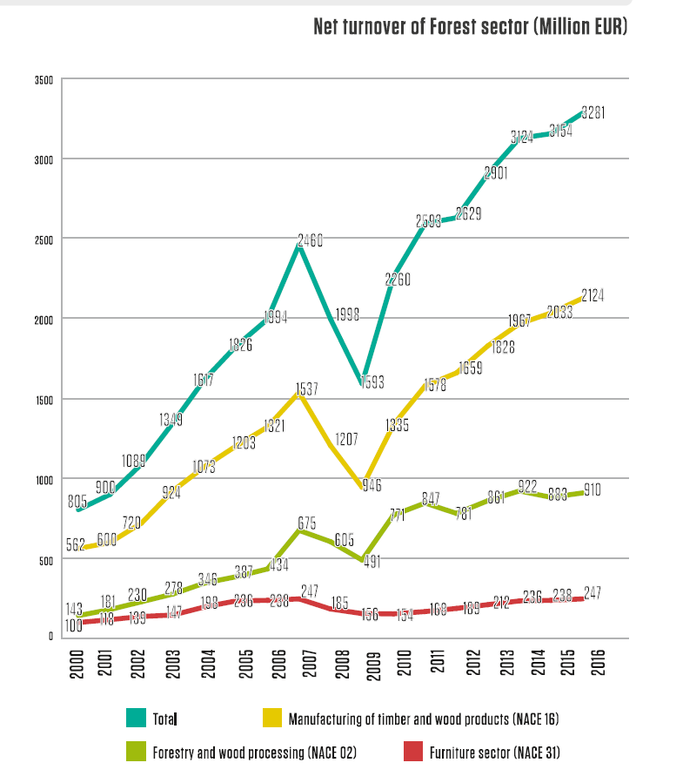

The forest sector in Latvia is traditionally one of the most important sectors of the national economy. The share of the forest sector in the gross domestic product is about six percent. The added value of forest sector products has increased significantly - from 295 million euros in 2000 to 1.4 billion euros in 2013.
Since 1993, the total export contribution of wood products has reached 21 billion euros, with a positive export-import balance in these years - 15 billion euros.
The forest sector plays a key role in providing employment for the population. The sector directly employs more than 54 thousand people, while together with related industries, forestry and the forest sector provide income for more than 80 thousand people. The forest sector plays a particularly important role in regional development and regional employment. For example, in the wood industry, about 80% of jobs are located in one of the regions of Latvia, and only 20% of jobs are located in Riga.

SIA PATA has 4 suppliers of SBP feedstock in Latvia. They deliver SBP-compliant Primary Feedstock from mix trees species.

Country | Lithuania
Area/Region | Aukštaitija, Samogitia, Dzūkija, Suvalkija, Lithuania Minor
Exclusions
Description of the country
Forests cover amounts to 33.3 per cent of the territory of the Republic of Lithuania and forest land constitute an area of 2 178 958 hectares as of 31st December 2017. Expansion of the forest area has been one of the main objectives of Lithuanian forestry policy over the last years. Due to the implementation of sustainable forest management and national afforestation measures, forest coverage in Lithuania has increased by 3 percent since 2003.
Approximately a half of forest land in Lithuania is owned by the State and managed by 42 State Forest Enterprises and the Directorate General of State Forests. Respectively, around 40 per cent of forest land is privately owned and the rest 10 per cent is still reserved for restitution.
Occupying 1 152 400 ha, coniferous stands prevail in Lithuania, covering 56.1 per cent of the forest area. They are followed by softwood deciduous forests (827 500 ha, 40.3 per cent) and hardwood deciduous forest (75 800 ha, 3.7 per cent). The dominant tree species are pine (occupying 720 300 ha) and spruce (429 600 ha). Birch stands are prevalent among deciduous trees, covering an area of 459 700 ha.
Sustainable forest management is the overriding objective for forest policy and practise in Lithuania. Therefore, forest resources are used responsibly and annual timber harvest rate does not exceed the annual increment. Lithuania’s forests produce around 7,4 million m³ of round wood per year. Annual fellings do not exceed 60 per cent of gross total annual increment.
Forests are divided into groups upon the objectives of the economic activities, their regime and the major functional purpose.
Group I – strict reserves forests. These are the strict reserves and small strict reserves forests on the territories of state strict nature reserves, state parks and biosphere monitoring territories. Objective of economic activities – to preserve the forests for a natural growth.
Group II – forests of special purpose, split into the following: A – ecosystem protection forests. Landscape, botanical, forest genetic, zoological, botanical-­zoological reserves and reserves of these types in state parks and biosphere monitoring territories. Objective of economic activities – to preserve or restore forest ecosystems or separate ecosystem components. B – recreational forests. Recreational forests cover forest parks, urban (city) forests, forests of recreation zones of the state parks, recreational forest areas and other forests defined for recreation. Objective of economic activities – to form and preserve the recreational forest environment.
Group III – protective forests. These are the forests in the territories of geological, geomorfological, hidrographical, and cultural reserves, forests of protection zones. Objective of economic activities – to form productive forest stands capable of performing the functions of protection of soil, air, water and human living surroundings.
Group IV – commercial forests, split into the following: A – commercial forests of normal cutting age. Objective of economic activities – to form productive forest stands and supply wood continuously following the requirements of environmental protection;; B -­ forest plantations. Objective of economic activities – to grow as much wood as possible in the shortest period of time.
FSC and PEFC certificates are used in Lithuania.
In December 2020 total FSC Certified Forest Area in Lithuania was 1 258 077 hectares and 416 Chain of Custody Certificates.
In December 2020 there were 15 PEFC Chain of Custody Certificates.
CITES came into force in Lithuania on 09/03/2002.

Forests and wood product industries provide over 60,000 jobs in forestry and logging, wood manufacturing and the paper and furniture industries. This is 6 percent of total employment in the country. In 2013 the forest and wood processing sector’s share of total national value added reached 4.5 percent, with forestry adding about 0.6 percent. The biggest share of the value added in the sector was generated by the furniture industry, some 2 percent. The number of companies in forestry, logging and the forest industry diminished while their average size increased in recent years. The Lithuanian forest and wood processing sector has over 2,000 operating companies as of 2014.

SIA PATA has not purchased SBP feedstock from Lithuania.

Country | Estonia
Area/Region | Coastal, Inland
Exclusions
Description of the country
Today forests cover around 50% of the territory of Estonia contributing to approximately 2.2 million hectares with the growing stock around 468 million m3. Estonia is in the third position in Europe based on forest coverage (share of forestland area in mainland territory) after Sweden and Finland.
Estonia lies within the latitude of 59° 00’N in the temperate zone of the Northern Hemisphere. Due to moderate maritime climate conditions for forest growth are very suitable. Estonia belongs primarily to the northern area of the nemoral-­coniferous or „mixed forest” belt. Of all the woodlands, 51% of stands are dominated by deciduous species and 49% by coniferous species making landscapes very diverse. Without the limiting influence of humans forests would cover most of Estonia’s mainland. In fact, 3,000 years ago more than 80% of the mainland was covered with forests. Due to human activity, 100 years ago forests covered only 30% of 4.5 million hectares of the total area of Estonia.
The diversity of forests in Estonia provides habitats for a large number of species.
“Estonian Forestry Development Program until 2020” is the framework document for the development of forestry in the current decade. The principal goals are to safeguard the productivity and viability of forests and ensure the varied and effective use of forests. In order to achieve these aims, it is important to procure wood in the amount of the increment, to increase the volume of reforestation, to keep at least 10% of forestland area under strict protection and to enhance the variety of protected forests. The share of strictly protected forests in the total area of forests was 10% already in 2010, but further efforts are required to ensure that a variety of forests are represented in the strictly protected areas. (Statistical Yearbook of Estonia 2014 – Statistics
Estonia) Private forest owners manage around 1.01 million ha (47%) of forest land in Estonia with the growing stock of around 275 million m3.
40% of the forests of Estonia belong to the state. These forests are maintained, grown and managed by the State Forest Management Centre (RMK).
FSC and PEFC certificates are used in Estonia.
In December 2020 total PEFC Certified Forest Area in Estonia was 1 295 989 hectares and 83 Chain of Custody Certificates.
In December 2020 total FSC Certified Forest Area in Estonia was 1 198 933 hectares and 289 Chain of Custody Certificates.
CITES came into force in Estonia on 20/10/1992.

Net turnover of Forest sector in Estonia (million EUR)
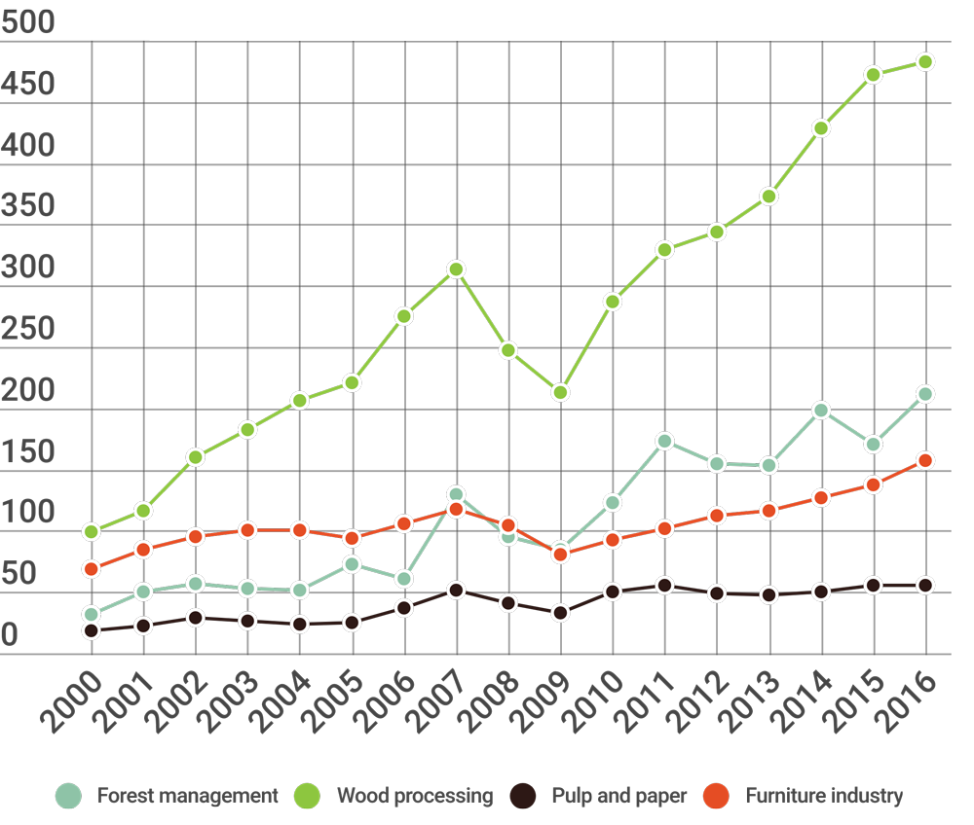

The share of Estonian forest and wood industries added value compared to Estonian GDP

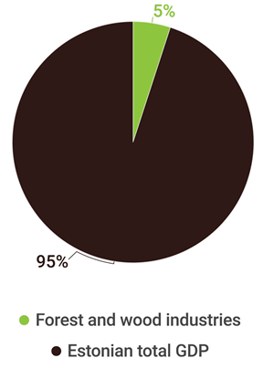

EMPLOYMENTNUMBERS
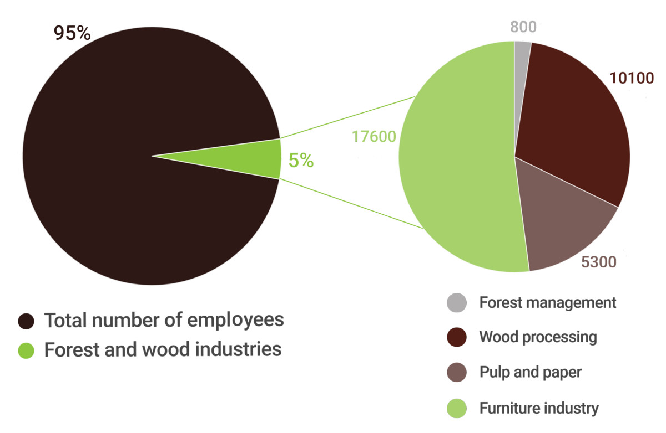

SIA PATA has not purchased SBP feedstock from Estonia.

Actions taken to promote certification amongst feedstock supplier
SIA PATA informs suppliers about criteria and importance of FSC and PEFC certificates.
SIA PATA also is informing suppliers about SBP objectives and requirements and importance to comply with them.
Feedstocks for biomass production are supplied from Latvian State Forests (FSC and PEFC certified) and small part from Latvian private forests (non certified). The main part of feedstocks – 85% - are FSC or PEFC certified.

Quantification of the Supply Base

Supply Base
- Total Supply Base area (million ha): 7.42
- Tenure by type (million ha):
  - Privately owned: 3.4
  - Public: 3.46
  - Community concession: 0.56

- Forest by type (million ha):
  - Boreal: 7.42
  - Temperate: 0
  - Tropical: 0
- Forest by management type (million ha):
  - Plantation: 0
  - Managed natural: 7.42
  - Natural: 0
- Certified forest by scheme (million ha):
  - FSC: 3.66
  - PEFC: 3.02
  - SFI: 0
  - Other (specify): 0

Describe the harvesting type which best describes how your material is sourced:
☐ Clearcutting ☐ Thinning ☒ Mix of the above ☐ Other ☐ N/A
Explanation: Max area of clear cut shall be 2-5 ha (it`s depend from forest type); in trees felling use harvesters and chainsaws.

Was the forest in the Supply Base managed for a purpose other than for energy markets?
☒ Yes – Majority ☐ Yes – Minority ☐ No ☐ N/A
Explanation: The main use of logs is the wood industry and furniture production

For the forests in the Supply Base, is there an intention to retain, restock or encourage natural regeneration within 5 years of felling?
☒ Yes – Majority ☐ Yes – Minority ☐ No ☐ N/A
Explanation: Specified in the Forest Law

Was the feedstock used in the biomass removed from a forest as part of a pest/disease control measure or a salvage operation?
☐ Yes – Majority ☐ Yes – Minority ☒ No ☐ N/A
Explanation:

Feedstock
Reporting period from date: 01/01/2020
Reporting period to date:31/12/2020
- Total volume of Feedstock:
☐ 0
☐ 1-200,000
☒ 200,000-400,000
☐ 400,000-600,000
☐ 600,000-800,000
☐ 800,000-1,000,000
☐ >1,000,000
Unit: ☒m3 ☐tonnes

- Volume of primary feedstock
☐ 0
☐ 1-200,000
☒ 200,000-400,000
☐ 400,000-600,000
☐ 600,000-800,000
☐ 800,000-1,000,000
☐ >1,000,000
Unit: ☒m3 ☐tonnes

- List percentage of primary feedstock, by the following categories.
  - Certified to an SBP-approved Forest Management Scheme:
☐ 0%
☐ 1%-19%
☐ 20%-39%
☐ 40% -59%
☒ 60%-79%
☐ 80-99%
☐ 100%
  - Not certified to an SBP-approved Forest Management Scheme:
☐ 0%
☐ 1%-19%
☒ 20%-39%
☐ 40% -59%
☐ 60%-79%
☐ 80-99%
☐ 100%

- List of all the species in primary feedstock, including scientific name::

Common name | Scientific name
Pine | Pinus sylvestris
Spruce | Picea abies
Birch | Betula pendula
Black alder | Alnus glutinosa
White alder | Alnus incana
Aspen | Populus tremula
Ash | Fraxinus excelsior
Oak | Quercus robur

- Is any of the feedstock used likely to have come from protected or threatened species?
☐ Yes ☒ No
Name of species:
Biomass proportion, by weight, that is likely to be composed of that species:
- Hardwood (i.e. broadleaf trees): specify proportion of biomass from (%): 88
- Softwood (i.e. coniferous trees): specify proportion of biomass from (%): 12
- Proportion of biomass composed of or derived from saw logs (%): 0
- Specify the local regulations or industry standards that define saw logs: NA
- Roundwood from final fellings from forests with > 40 yr rotation times - Average % volume of fellings delivered to BP (%): 50
- Volume of primary feedstock from primary forest: 0
Unit: ☒m3 ☐tonnes
- List percentage of primary feedstock from primary forest, by the following categories. Subdivide by SBP-approved Forest Management Schemes:
  - ☒ N/A
  - Primary feedstock from primary forest certified to an SBP-approved Forest Management Scheme:
☐ 0%
☐ 1%-19%
☐ 20%-39%
☐ 40% -59%
☐ 60%-79%
☐ 80-99%
☐ 100%

- Primary feedstock from primary forest not certified to an SBP-approved Forest Management Scheme:
☐ 0%
☐ 1%-19%
☐ 20%-39%
☐ 40% -59%
☐ 60%-79%
☐ 80-99%
☐ 100%

- Volume of secondary feedstock:
☒ 0
☐ 1-200,000
☐ 200,000-400,000
☐ 400,000-600,000
☐ 600,000-800,000
☐ 800,000-1,000,000
☐ >1,000,000
Unit: ☐m3 ☐tonnes
Physical form of the feedstock:
☐ Chips
☐ Sawdust
☐ Offcuts
☐ Clean chips or dust
☐ Treated chips or dust
☐ Other (specify):

- Volume of tertiary feedstock:
☒ 0
☐ 1-200,000
☐ 200,000-400,000
☐ 400,000-600,000
☐ 600,000-800,000
☐ 800,000-1,000,000
☐ >1,000,000
Unit: ☐m3 ☐tonnes
Physical form of the feedstock:
☐ Shavings
☐ Sawdust (dry)
☐ Offcuts
☐ Other (specify):
Proportion of feedstock sourced per type of claim during the reporting period

Feedstock type | SBE % | FSC % | PEFC % | SFI %
Primary | 30 | 10 | 60 | 0
Secondary | 0 | 0 | 0 | 0
Tertiary | 0 | 0 | 0 | 0
Note: Sum of each row for feedstock types used has to be 100%

Requirement for a Supply Base Evaluation
SBE completed | SBE not completed
X | ☐

SBP biomass supply evaluation includes:
- Primary wood (round wood) after logging
SIA PATA defines the feedstock/biomass received from the approved sources and supplies as a “SBP-compliant biomass”.
SBP-endorsed Regional Risk Assessments for Latvia, Estonia and Lithuania are used. Company has been developed inspection program for supply risk mitigation.
The risk assessment is divided into : “low risk”, “specified risk” or “unspecified risk”.

Supply Base Evaluation

Scope
Feedstock types included in SBE: ☒ Primary ☐ Secondary ☐ Tertiary
SBP-endorsed Regional Risk Assessments used: Yes
List of countries and regions included in the SBE: Latvia, Lithuania, Estonia
Detailed description of specified risk indicators:
Country: Latvia
Indicator with specified risk in the risk assessment used:
2.1.1 Forests and other areas with high conservation values in the Supply Base are identified and mapped
Specific risk description:
High Conservation Value Forests, category 3: include Natura 2000 sites, EU protected habitats, Woodland key habitats - the risk level for this subcategory is considered to be specified risk for non-certified forests.
High Conservation Value Forests, category 6: Forest and parks in or around objects of cultural heritage, for instance, manor parks, urban forests, forests of important historical sites - there is no information compiled on the cultural heritage of such forests and the actual cultural heritage status is not fully acknowledged in private, municipal and church owned forests.
Country: Latvia
Indicator with specified risk in the risk assessment used:
2.1.2 Potential threats to forests and other areas with high conservation values from forest management activities are identified and addressed.
Specific risk description:
High Conservation Value Forests, category 1: With regard to identification and protection of conservation values, there is an expert concern about nesting areas of a number of species included in the Bird’s Directive Annex I which are not identified and registered in the forest register databases and thus “de facto” are not protected outside protected nature territories with special protection regimes.
High Conservation Value Forests, category 3: Problematic areas in relation to threats to forests and other areas with high conservation values, are nature values in woodland key habitats (WKH) and/or EU protected forest habitats in non-certified forests.
High Conservation Value Forests, category 6: isolated cases of destruction/damaging of objects of cultural heritage in private forests.
Country: Latvia
Indicator with specified risk in the risk assessment used:
2.8.1 Appropriate safeguards are put in place to protect the health and safety of forest workers.
Specific risk description:
Low risk can be considered for: • companies working as subcontractors for certified forest managers and who are routinely checked for OH&S issues or are implementing quality management systems in relation to OH&S issues (OHSAS 18001 for example); • harvesting works which are carried out exclusively with forest machinery (harvesters). “Specified risk” is considered for: Harvesting works which are carried out by manual harvesting means (chainsaws) in noncertified forests. Special focus shall be paid to self-employed persons and workers of microenterprises.

Country: Lithuania
Indicator with specified risk in the risk assessment used:
2.1.2 Potential threats to forests and other areas with high conservation values from forest management activities are identified and addressed.
Specific risk description:
The indicator is identified as low risk for state forest enterprises and specified risk for private forest.
Country: Lithuania
Indicator with specified risk in the risk assessment used:
2.8.1 Appropriate safeguards are put in place to protect the health and safety of forest workers.
Specific risk description:
Within the EU forest sector, Lithuania is the country with the highest risk in relation to health and safety. There is a concern about contractors working in private forest because of periodically occurring fatal and serious injuries at the work place. In addition, there are not sufficient measures to ensure that contractors working in private forest follow the health and safety requirements, therefore it was decided to assign specified risk to this indicator for the contractors working in private forest.

Country: Estonia
Indicator with specified risk in the risk assessment used:
2.1.2 Potential threats to forests and other areas with high conservation values from forest management activities are identified and addressed.
Specific risk description:
In state forest, FSC or PEFC-certified private forest, and in private forests where a WKH contract has been signed, WKH are protected.
The risk level for this indicator in uncertified private forest is specified and low for state forest and FSC or PEFC-certified private forest.

Justification
SBP endorsed SBP Regional Risks Assessments have been developed in accordance with SBP standard Nr.1 version 1.0 of March 2015 and SBP standard Nr.2 version 1.0 of March 2015, assessing the risk category for each SBP indicator. Through reviewing and assessing the risk, the company acquired an in-depth understanding of the wood supply risks that could affect the acceptance of SBP non-compliant material for biomass production.
By introducing efficient risk mitigation measures, the company has the option to purchase SBP approved and compliant assortment to produce the required amount of “SBP compliant biomass” products.
SIA PATA as forest company with 20 years expierence, integrating leading expertise in forest industry, has developed risk mitigation and control mechanism for the evaluation and confirmation of its biomass which comply with the “SBP compliant biomass” status.

Results of risk assessment and Supplier Verification Programme
Taking into account the specifik characters of Latvia and expert advice and recommendations, “specified risk” was applied in relation to identification and protection of EU importance and natural forest habitats, bird species, identification and protection of cultural heritage objects (HCV category 3) in non-certificate forests and work safety( if work with chainsaw in non-certificate forests).

In Estonia “specified risk” was applied only to biotope protection in non-certificate private forests.

In Lithuania “specified risk” was applied to biotope protection and work safety in private forests.

Supplier Verification Programme does not apply in PATA case, since we did not identify “unspecified risk” in PATA Supply Base Evaluation.

Conclusion
Since Juny 1, 2018 when the requirements of SBE standarts were initiated and introduced, the compliance of feedstock suppliers to specific risks was reviewed. The suppliers who are informed and competent on assessment of possible risks, but who are not certified by requirements of PEFC or FSC standarts, are approved as SBP wood suppliers.
The volume of FSC or PEFC certified wood is not enough to ensure that 100% of the biomass is a “SBP compliant biomass”.
As a result of risk mitigation measures, SIA PATA has confirmed that the suppliers who logging round wood at self own or other own forests and hand in all requested information, can be provided risk mitigation measures and conform to SBE low-risk category at supply level.

Supply Base Evaluation process
SIA PATA “SBP compliant biomas” assessment refers to supplies from Latvia, Lithuania and Estonia, and obtaining of biomass from :
- SBP-approved forestry certification scheme;
- SBP-approved supply chain (CoC) system;
- SBP low risk feedstocks sourced within SBE system.
The company has developed and implemented a risk mitigation procedure where the identified risk mitigation measures and tools are described.
Checking questionnaires to each specified risk indicator were designed and applied to objectively assess and obtain all information on each wood extraction site, which is approved as “SBP compliant biomass” or “SBP compliant feedstock”.
Check frequency and plan is designed so that all suppliers are checked one time per year.
Approved suppliers cutting places are checked by OZOLS data base - https://www.daba.gov.lv/public/lat/dati1/dabas_datu_parvaldibas_sistema_ozols/ (in Latvia); http://register.metsad.ee and https://ee.fsc.org/ee-ee/fsc-sertimine/kontrollitud-puit/vaeaeriselupaigad and https://hiiepaik.maps.arcgis.com/apps/webappviewer/index.html?id=09558607d1dd4c07acc46c338b2196ac (in Estonia) - private forest owners can sign contract with the state and protect WKH or each time before felling forest owners determine the location of WKH;
www.geoportal.lt www.natura2000info.lt (in Lithuania) – in Lithuania natural forest habitats and WKH designated as Natura 2000 sites at the EU level or biosphere polygons at the national level.
Checking are performed prior to or during logging. The checking procedure is available at the company only by request, taking into account confidentiality, and is discussed with interested parties to improve it effectively.
As the basis for the establishment of the SBP and SBE risk mitigation system, there were taken requirements of the PEFC Supply chain certification system standarts, staff competence in the wood supply chain as well as knowledge in forestry, wood industry and the legality of wood supplies.

Stakeholder consultation
On 27 April 2018, the company published the SBP risk assessments and the draft SBR on its website. An informative letter was sent electronically to the interested parties on the risk assessment and draft SBR. The list of interested parties was created so that it includes the maximum number of recipients that represent economic, social and environmental interests of society, as well as local municipalities. The total number of recipients is 42 correspondent.

SBR is available on the company`s website: https://pata.lv/en/about-us/

Response to stakeholder comments
After the stakeholder informed, no recommendations or claims were received regarding the risk assessment and risk mitigation development process.

Mitigation measures

Mitigation measures
Country: Latvia
Indicator with specified risk in the risk assessment used:
2.1.1 Forests and other areas with high conservation values in the Supply Base are identified and mapped
Specific risk description:
High Conservation Value Forests, category 3: include Natura 2000 sites, EU protected habitats, Woodland key habitats - the risk level for this subcategory is considered to be specified risk for non-certified forests.
High Conservation Value Forests, category 6: Forest and parks in or around objects of cultural heritage, for instance, manor parks, urban forests, forests of important historical sites - there is no information compiled on the cultural heritage of such forests and the actual cultural heritage status is not fully acknowledged in private, municipal and church owned forests.
Mitigation measure: Performing areas with high conservation values risk assessment procedures prior to logging and checking cadastre numbers using the https://www.daba.gov.lv/public/lat/dati1/dabas_datu_parvaldibas_sistema_ozols/.

Country: Latvia
Indicator with specified risk in the risk assessment used:
2.1.2 Potential threats to forests and other areas with high conservation values from forest management activities are identified and addressed.
Specific risk description:
High Conservation Value Forests, category 1: With regard to identification and protection of conservation values, there is an expert concern about nesting areas of a number of species included in the Bird’s Directive Annex I which are not identified and registered in the forest register databases and thus “de facto” are not protected outside protected nature territories with special protection regimes.
High Conservation Value Forests, category 3: Problematic areas in relation to threats to forests and other areas with high conservation values, are nature values in woodland key habitats (WKH) and/or EU protected forest habitats in non-certified forests.
High Conservation Value Forests, category 6: isolated cases of destruction/damaging of objects of cultural heritage in private forests.
Mitigation measure: Performing biotope risk assessment procedures prior to logging and checking cadastre numbers using the https://www.daba.gov.lv/public/lat/dati1/dabas_datu_parvaldibas_sistema_ozols/.
Country: Latvia
Indicator with specified risk in the risk assessment used:
2.8.1 Appropriate safeguards are put in place to protect the health and safety of forest workers.
Specific risk description:
Low risk can be considered for: • companies working as subcontractors for certified forest managers and who are routinely checked for OH&S issues or are implementing quality management systems in relation to OH&S issues (OHSAS 18001 for example); • harvesting works which are carried out exclusively with forest machinery (harvesters). “Specified risk” is considered for: Harvesting works which are carried out by manual harvesting means (chainsaws) in noncertified forests. Special focus shall be paid to self-employed persons and workers of microenterprises.
Mitigation measure: An assessment form is designed where minimal requirements for maintaining work safety in the forest are included.

Country: Lithuania
Indicator with specified risk in the risk assessment used:
2.1.2 Potential threats to forests and other areas with high conservation values from forest management activities are identified and addressed.
Specific risk description:
The indicator is identified as low risk for state forest enterprises and specified risk for private forest.
Mitigation measure: : Performing biotope risk assessment procedures prior to logging and checking cadastre numbers using the www.geoportal.lt www.natura2000info.lt
Country: Lithuania
Indicator with specified risk in the risk assessment used:
2.8.1 Appropriate safeguards are put in place to protect the health and safety of forest workers.
Specific risk description:
Within the EU forest sector, Lithuania is the country with the highest risk in relation to health and safety. There is a concern about contractors working in private forest because of periodically occurring fatal and serious injuries at the work place. In addition, there are not sufficient measures to ensure that contractors working in private forest follow the health and safety requirements, therefore it was decided to assign specified risk to this indicator for the contractors working in private forest.
Mitigation measure: An assessment form is designed where minimal requirements for maintaining work safety in the forest are included.
Country: Estonia
Indicator with specified risk in the risk assessment used:
2.1.2 Potential threats to forests and other areas with high conservation values from forest management activities are identified and addressed.
Specific risk description:
In state forest, FSC or PEFC-certified private forest, and in private forests where a WKH contract has been signed, WKH are protected.
The risk level for this indicator in uncertified private forest is specified and low for state forest and FSC or PEFC-certified private forest.
Mitigation measure: : Performing areas with high conservation values risk assessment procedures prior to logging and checking cadastre numbers using http://register.metsad.ee and https://ee.fsc.org/ee-ee/fsc-sertimine/kontrollitud-puit/vaeaeriselupaigad and https://hiiepaik.maps.arcgis.com/apps/webappviewer/index.html?id=09558607d1dd4c07acc46c338b2196ac

Monitoring and outcomes
The suppliers that refuse to cooperate with SIA PATA in the identification of the preserve biotopes, protected bird species, cultural heritage objects and complying with work safety requirements, thus mitigated the risk of supplying SBP non-compliant feedstocks, were not approved for wood supply.

All suppliers are checked in OZOLS database for existing preserve biotopes, thus provide SBP compliant feedstocks supplies.

After SBP risk mitigation inspections, as well as creation of information materials, the supplier and forest owner have developed an understanding of SBE requirements regarding risk categories, their recognition and mitigation mechanism.

In 2020, PATA has 4 suppliers of feedstocks for production of SBP-compliant biomass.

Detailed findings for indicators
Detailed findings for each Indicator are given in Annex 1 in case the Regional Risk Assessment (RRA) is not used.
Is RRA used?
☒ Yes ☐ No

Review of report

Peer review
No external peer review was carried out.

Public or additional reviews
No additional information for the time being.

Approval of report
Approval of Supply Base Report by senior management
Report Prepared by: | Vita Rudzīte | Certification system manager | 16.03.2021.
 | Name | Title | Date
The undersigned persons confirm that I/we are members of the organisation’s senior management and do hereby affirm that the contents of this evaluation report were duly acknowledged by senior management as being accurate prior to approval and finalisation of the report.
Report approved by: | Jānis Mierkalns | Member of the Board | 19.03.2021.
 | Name | Title | Date
Report approved by:
 | Name | Title | Date
Report approved by:
 | Name | Title | Date

